**VERSOES DO WORDPRESS:** 0.72, 1.0, 1.2, 1.5, 2.0 ,2.1 ,2.2 ,2.4 ,2.5 ,2.6 ,2.8 ,2.9 ,3.0 ,3.1 ,3.2 ,3.3 ,3.4 ,3.5, 3.6, 3.7 ,3.8 ,3.9 ,4.0 ,4.2 ,4.3 , 4.4 ,4.5, 4.6, 4.7.

WordPress 4.7 will be the last major release of 2016. As is the tradition, it will come with a new default theme for the next year.

Twenty Seventeen is slightly different than previous default themes. Its main focus is on business websites rather than blogs, and it even comes with starter content to help new users [setup their WordPress websites](http://www.wpbeginner.com/free-wordpress-blog-setup/). Currently the starter content feature is available for new sites only, but by the time the theme is released, it is expected to be available for sites with existing content as well.

It can also be used as a [blog theme](http://www.wpbeginner.com/showcase/43-beautiful-free-wordpress-blog-themes/). Twenty Seventeen has large featured images, crisp typography, and a mobile-first approach to design.

**Video Headers Support**

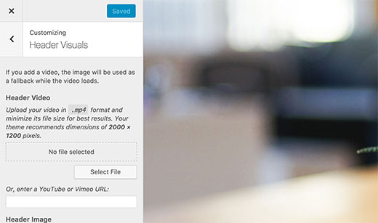

Many [premium WordPress themes](http://www.wpbeginner.com/beginners-guide/decide-premium-free-wordpress-themes/) are already allowing users to add video headers. Twenty Seventeen will be the first default theme to come with video header support.

You can upload and use your own videos in mp4 format, or you can also use YouTube and Vimeo videos by simply entering the video URL.

If your theme doesn’t support video headers, here is how you can easily add [YouTube video as fullscreen background in WordPress](http://www.wpbeginner.com/plugins/how-to-add-youtube-video-as-fullscreen-background-in-wordpress/) without any coding.

**Theme Setup Flow**

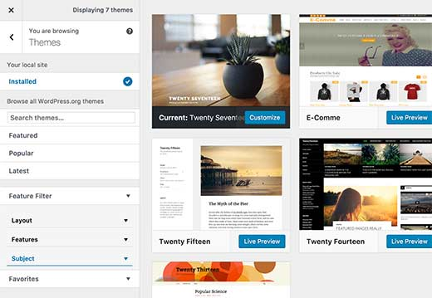

WordPress 4.7 will bring an improved theme and site setup flow. In the customizer, you will now see a more polished view of your installed themes, better theme search, and improved setup directly from theme customizer.

**Custom CSS in Live Preview**

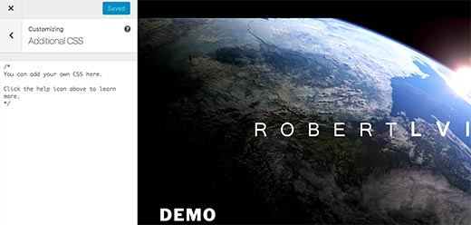

Want to add custom CSS to your theme? Now you can do that directly from the theme customizer. However, your custom CSS will be specific to the theme you are previewing.

If you often change themes or don’t want your custom CSS limited to a theme, then you can see our guide on [how to easily add custom CSS in WordPress](http://www.wpbeginner.com/plugins/how-to-easily-add-custom-css-to-your-wordpress-site/).

**Admin Language Control for Users**

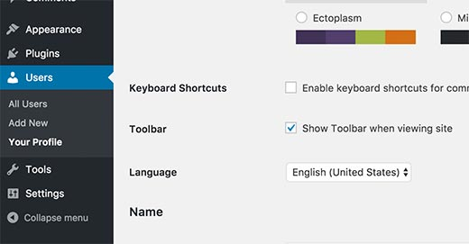

Currently when you install WordPress in other languages, all users see the admin interface in the same language.

WordPress 4.7 will allow users to switch the admin language from their user profile, so each user can choose the language they prefer. You will still need to [install the languages](http://www.wpbeginner.com/wp-tutorials/how-to-install-wordpress-in-other-languages/) before users can switch them.

**Thumbnail Previews for PDF Files**

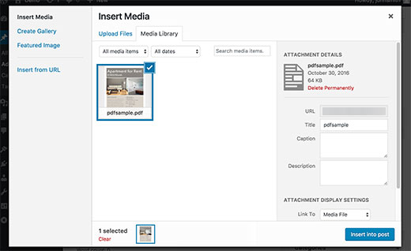

Currently, if you upload a PDF file, then WordPress only shows the file icon. You can add previews using [PDF plugins for WordPress](http://www.wpbeginner.com/plugins/best-pdf-plugins-for-wordpress/).

WordPress 4.7, will show thumbnail preview of the first page in your PDF document when you upload it to the media library. WordPress will also display thumbnail previews on a PDF file’s [attachment page](http://www.wpbeginner.com/glossary/attachment/).

**Editor Enhancements**

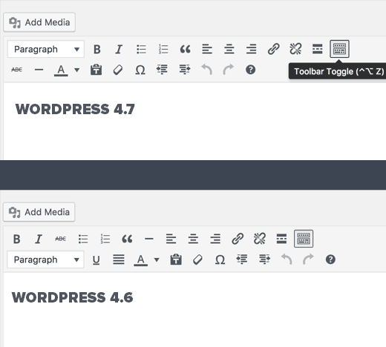

The [post editor](http://www.wpbeginner.com/beginners-guide/14-tips-for-mastering-the-wordpress-visual-editor/) is where most site owners spend most of their time creating content. Each WordPress version brings enhancements and features to the post editor.

WordPress 4.7 will make some subtle but important changes to the editor. The paragraph and heading selector menu will now appear in the top bar. The underline button has been removed, and the strikethrough and horizontal line buttons are moved to the kitchen sink bar.

Users will also be able to see [keyboard shortcuts](http://www.wpbeginner.com/beginners-guide/21-most-useful-time-saving-wordpress-shortcuts/) in tooltips and drop down menus.

**Under The Hood Improvements**

These updates improve significant parts of the WordPress core but are mainly intended for developers.

**Custom Bulk Actions**

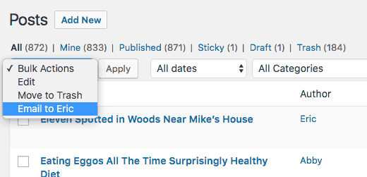

Developers will now be able to add their own custom bulk actions to list tables on different admin screens like posts, comments, users, etc. ([#16031](https://core.trac.wordpress.org/ticket/16031))

**Post Type Templates**

Similar to custom page templates, Post Type Templates will allow theme developers to add the ability to choose templates for different post types. ([#18375](https://core.trac.wordpress.org/ticket/18375))

**Rest API Content Endpoints**

Rest API Endpoints will make their way into WordPress 4.7. ([#38373](https://core.trac.wordpress.org/ticket/38373))

**Locale Switching**

If the content of your website is displayed in a different locale than the one set in admin area, then WordPress will show the toolbar in the language of the content page. ([#26511](https://core.trac.wordpress.org/ticket/26511))

We hope this article helped you learn what’s coming in WordPress 4.7. Let us know which features you find exciting and what you would like to see in future releases of WordPress in the comments below.

If you liked this article, then please subscribe to our [YouTube Channel](http://youtube.com/wpbeginner?sub_confirmation=1) for WordPress video tutorials. You can also find us on [Twitter](http://twitter.com/wpbeginner" \o "WPBeginner on Twitter" \t "_blank) and [Facebook](https://www.facebook.com/wpbeginner" \o "WPBeginner on Facebook" \t "_blank).